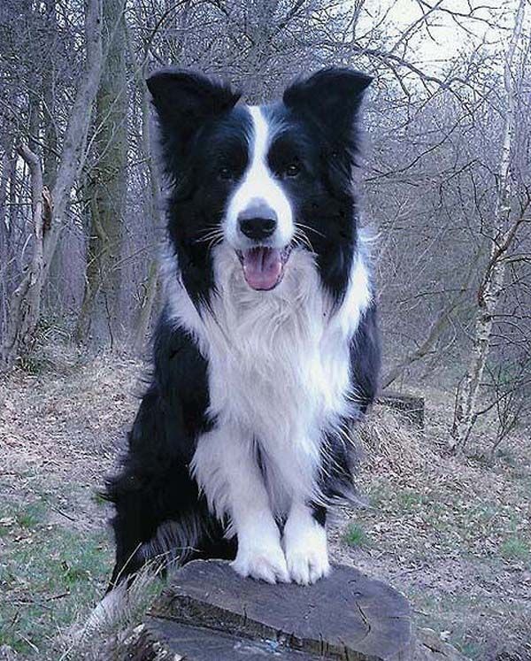
JOP's SHOW RESULTS:
Youth Winner, Amsterdam 1999
Luxembourg Show Champion 2001
Belgian Winner 2001
Dutch Show Champion 2002
Belgian Show Champion 2003
Champions Class World Winner 2002: Excellent 4, Amsterdam
International Show Champion 2003
Qualifier Crufts for live
2nd Place Special Working Trial Class CRUFTS 2004

In his first sheepdog trial, he was one of the prizewinners.
He's tested for Hip-dysplasia, score negative or A (totally free of hipdysplasia)
Jop is Optigen tested clear for CEA, also tested clear for CL and TNS ( university of NSW, Alan Wilton ).
Jop is selectively available for breeding.

*****

Jop's parents:

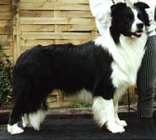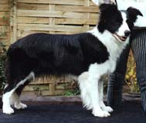
Sire : BEAGOLD MR. LENNOX Dame : MOBELLA TEAM SPIRIT AT TONKORY

--- Show results Mr. Lennox : SH. CH. (BEL.GB.96, U.S.A.97, LUX.98, NED.98), EUR. W. '98,
BELG.W. '97- '98 , BUNDESSIEGER 2000
--- Show results Team Spirit : SH. CH. GB., SH. CH. LUX, Best Border Collie WK '97,
Best Breeding Bitch '99

